1. a) With relevant examples, discuss the 4 important roles and responsibilities of a software project manager.
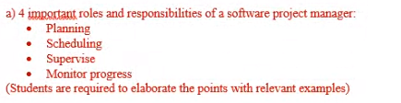

b) List and explain the 6 management activities need to handle by a software project manager.
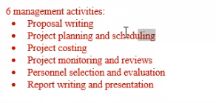

2. ZenHardware Sdn Bhd is a local company established for more than ten years. Recently the company is planning to automate their customer service processes through an online system. They have identified a list of functions the online system must include. Basically there are two main modules which are customer module and administrator module. Customer can request/update/cancel a hardware service ticket, track their hardware service records, update their profile and invoke a live chat with sales representative. Your company is contacted by ZenHardware Sdn Bhd to handle the project with a budget of RM10,000 within three months duration. This project has been approved by your company’s top management. You are given full authority to select your own team members from other departments.

As a project manager, briefly write a proposal to your management regarding this project. Your proposal should include the objective(s) of the project, cost, and schedule.
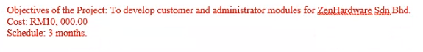

3. Managing a project group is one of the challenging and critical management tasks in software development projects. Discuss 4 factors that you would look into to improve the motivation and productivity level of a project group.
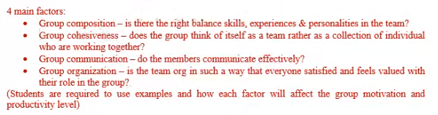

- Anderson is starting up a new company to provide Internet of Things (IoT) services in automating data collection from building construction and send notification to the users based on the data collected. For example, if the noise level has exceeded the safety measurement, IoT detector will alert all the workers to take some corrective actions. Another example is the electrical equipments used in the wet construction must not exceed 110V. Anderson has hired three senior software engineers in developing the IoT applications. The applications will be developed phase by phase in order to provide end-to-end solutions. Anderson plans to get the first version of IoT service for building construction hazard control application ready in the market within two months.

In project management, a project manager would need to consider the factors that could motivate employees throughout the project. Suggest and explain 2 motivating factors in this case based on Maslow Motivation Model.

5. Construct a Gantt Chart for developing an online system based on the following table.

Assume that the project starts in January.
Task ID | Task Description | Predecessor | Duration (month) | Overlap  (month)
A | Form project teams and gather user requirements | None | ¼ | None
B | Plan project | A | ½ | None
C | Business modeling | B | 1 | ¼
D | Data modeling | C | 1 | ¼
E | Process modeling | C | 1 | ¼
F | Application generation | E | 1 ½ | ½
G | Testing & Turnover | F | ½ | ¼
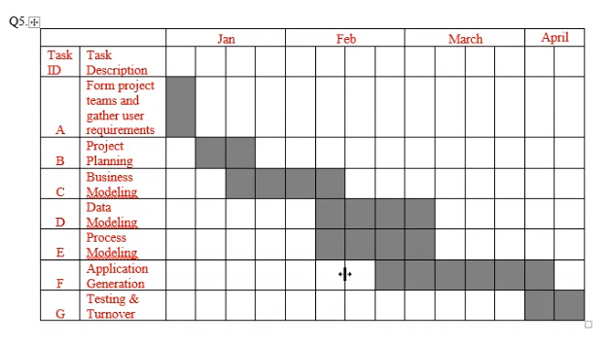

- WildLife Wonderland is a veterinary, pet food and pet care shop. It is a small scaled family business founded in 1990s. Recently the shop owner, Anderson, plans to sell its products online. He has contacted your company, a software house, to handle this project.

Prepare a Gantt Chart to develop the online pet shop system based on the following table. Assume that the project starts in February.

Task ID | Task Description | Predecessor | Duration (month) | Overlap  (month)
A | Requirement gathering | None | ¼ | None
B | Prototype 1 | A | ¼ | None
C | Customer feedback | A | ¼ | None
D | Prototype 2 | C | ¼ | None
E | Customer feedback | C | ¼ | None
F | Prototype 3 | E | ¼ | None
G | Customer feedback | E | ¼ | None
H | Coding | G | 1 | None
I | Testing | H | ½ | ½
J | Deployment | I | ¼ | None

